STEP 1: KNOWLEDGE BASE AND SELF-ASSESSMENT FORM GENERATION

DJANGO BACKEND

ER CHANGES

Before
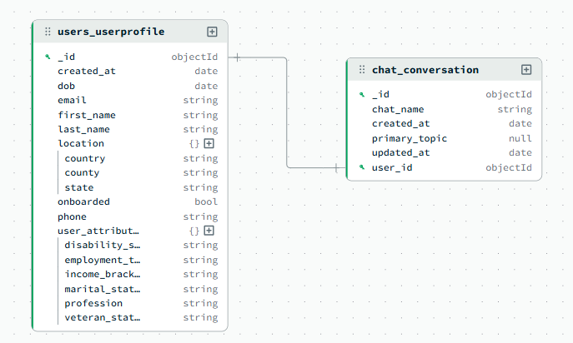

After
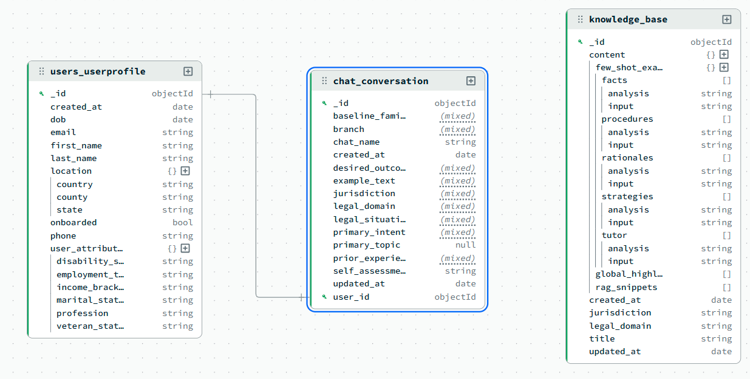

AI LAYER

EXAMPLE
Description | Traffic law — red light camera ticket — user wants to contest
Legal Situation | I received a red light camera ticket in Phoenix with a fine of $300
Prior Experience | Yes, I contested a speeding ticket successfully two years ago
Desired Outcome | I want to contest this ticket and get it dismissed
Jurisdiction | Arizona

LLM1 — Domain Classifier
Model: gpt-4o-mini | Latency: 2,582ms | Tokens: 996
Prompt
You are a legal domain classifier for a legal information chatbot.
Given the user's legal situation and their jurisdiction, classify the situation
into the most appropriate legal domain, branch, baseline familiarity, and primary intent.

---
STEP 1 - Classify primary_intent FIRST before anything else.
Use ONLY these definitions:

- understand_options: user wants to know what legal choices or rights they have
- contest: user wants to challenge, dispute, or fight against a decision,
charge, ticket, or refusal
- comply: user wants to fulfill a legal obligation correctly
- draft: user wants to create a new legal document from scratch
- review: user wants to examine and understand an existing document they
have ALREADY RECEIVED

Key distinction — review vs understand_options:
- "I want to understand this contract before I sign it" -> review
- "I want to know if I can get out of my contract" -> understand_options

---
STEP 2 - Classify legal_domain and branch.
Branch should describe the TYPE OF LEGAL SITUATION, not the desired outcome.

Available domains and example branches:
- traffic_law: speeding_ticket, red_light_violation, dui, reckless_driving,
parking_violation, license_suspension
- [... other domains omitted for brevity ...]

---
STEP 3 - Classify baseline_familiarity from prior_experience:
- low: no prior experience with legal matters
- medium: some relevant experience but no formal legal knowledge
- high: has dealt with this type of situation multiple times or has formal
legal background or training

Return strict JSON:
{
"legal_domain": "string",
"branch": "string",
"baseline_familiarity": "low | medium | high",
"primary_intent": "understand_options | contest | comply | draft | review",
"confidence": float,
"reasoning": "string"
}

User inputs:
Legal situation: I received a red light camera ticket in Phoenix with a fine of $300
Jurisdiction: arizona
Prior experience: Yes, I contested a speeding ticket successfully two years ago
Desired outcome: I want to contest this ticket and get it dismissed

Response
{
"legal_domain": "traffic_law",
"branch": "red_light_violation",
"baseline_familiarity": "medium",
"primary_intent": "contest",
"confidence": 0.95,
"reasoning": "The user wants to challenge a red light camera ticket, which falls
under traffic law specifically related to red light violations. They have some
relevant experience from contesting a speeding ticket previously, indicating a
medium level of familiarity with legal matters in this domain."
}

LLM2 — Knowledge Base Generator
Model: gpt-4o | Latency: 16,216ms | Tokens: 2,251 | Runs in parallel with LLM4

Prompt
You are a legal knowledge base architect generating a reusable, high-accuracy
knowledge base for a legal information chatbot.

Focus domain: traffic_law
Focus branch: red_light_violation
Focus jurisdiction: arizona
User legal situation: I received a red light camera ticket in Phoenix with a fine of $300

Field Requirements:
1. global_highlights (minimum 10): key legal facts, statutes, procedures
specific to traffic_law/red_light_violation in arizona.
Every item must be actionable for someone in the user's situation.
2. rag_snippets (min 8): self-contained legal reference paragraphs.
3. few_shot_examples (facts, strategies, procedures, rationales, tutor):
>= 2 input/analysis pairs each.
4. cot_checklist (min 5): chain-of-thought reasoning steps.

Return strict JSON matching the KB schema.

Response

Title: Comprehensive Guide to Traffic Law in Arizona

Global Highlights (10)
1. Arizona Revised Statutes (ARS) Title 28 governs traffic laws,
including red light violations.
2. In Arizona, red light camera tickets are considered civil traffic
violations, not criminal offenses.
3. The fine for a red light camera ticket in Phoenix can vary, but it
generally ranges around $300.
4. Arizona law requires that the notice of violation be mailed within
90 days of the violation date.
5. Drivers have the right to contest a red light camera ticket in court,
and they may request a hearing.
6. Failure to respond to a red light camera ticket can result in additional
fines and a default judgment.
7. Arizona does not add points to your driving record for red light camera
tickets, unlike officer-issued tickets.
8. The city of Phoenix contracts with private companies to operate and
maintain red light cameras.
9. Arizona law mandates that red light cameras must be clearly marked
with visible signage.
10. The registered owner of the vehicle is typically held responsible for
the ticket unless they can prove they were not driving.

RAG Snippets (8)
1. Under ARS §28-645, running a red light is a civil traffic violation in
Arizona, which includes violations captured by red light cameras.

2. In Phoenix, red light camera systems are used to enhance traffic safety
by deterring red light running and reducing collisions.

3. If you receive a red light camera ticket in Arizona, you have the option
to pay the fine, contest the ticket, or attend a defensive driving course
if eligible.

4. The notice of violation must include a photograph of the vehicle and driver,
the location, and the time of the violation.

5. Contesting a red light camera ticket in Arizona involves appearing in court
and presenting evidence or arguments to refute the violation.

6. Arizona law allows you to transfer liability for a red light camera ticket
if you were not the driver by providing an affidavit.

7. Red light camera tickets in Arizona do not affect your insurance rates as
they are civil violations and do not add points to your record.

8. The process for handling red light camera tickets in Arizona is governed
by local municipal courts, which have specific procedures for these cases.

Few-Shot Examples — Facts
Input: Do red light camera tickets add points to my driving record in Arizona?
Analysis: No, red light camera tickets do not add points to your driving record
in Arizona. They are considered civil violations rather than criminal infractions.
Unlike officer-issued tickets, camera tickets are treated differently under
Arizona law. A common misconception is that all traffic tickets impact your
driving record, but this is not the case with red light camera violations.

Input: Is the fine for a red light camera ticket the same across Arizona?
Analysis: The fine can vary depending on the jurisdiction within Arizona. In
Phoenix, the fine is typically around $300. Other cities may have different
fine structures based on local ordinances. Fines are not standardized across
the state, so always check the specific details on the ticket you received.

Few-Shot Examples — Strategies
Input: How can I contest a red light camera ticket in Phoenix?
Analysis: To contest in Phoenix, request a court hearing by following the
instructions on the ticket notice. At the hearing, present evidence or arguments
to dispute the violation. Prepare by gathering documentation such as evidence
you were not the driver. Many people mistakenly believe they cannot contest
these tickets, but Arizona law provides this option.

Input: What should I do if I wasn't driving when the ticket was issued?
Analysis: You can submit an affidavit identifying the actual driver. This involves
filling out a form provided with the ticket notice and may require additional
documentation. Act promptly to avoid a default judgment. A common pitfall is
ignoring the ticket, which can lead to increased fines.

Few-Shot Examples — Procedures
Input: What are the steps to pay a red light camera ticket in Arizona?
Analysis: Follow the instructions on the notice of violation. You can typically
pay online, by mail, or in person at the court specified on the ticket. Pay
by the due date to avoid additional penalties. Confirm payment receipt to
prevent future disputes about unpaid fines.

Input: How do I know if I'm eligible for a defensive driving course?
Analysis: Eligibility depends on violation type and driving history. Generally,
you cannot have attended a course for a similar violation within 12 months.
Check the ticket details or contact the court for specific criteria. A common
mistake is assuming eligibility without verification.

Few-Shot Examples — Rationales
Input: Why don't red light camera tickets affect my insurance rates in Arizona?
Analysis: Camera tickets are classified as civil violations, which do not add
points to your driving record. Consequently, they do not impact insurance rates.
This distinction separates automated enforcement from officer-issued tickets.
Many drivers incorrectly assume all tickets affect insurance.

Few-Shot Examples — Tutor
Input: Can I ignore a red light camera ticket in Arizona?
Analysis: Ignoring a red light camera ticket is not advisable. Failing to respond
can result in additional fines and a default judgment. The court may send the
case to collections. Address the ticket by paying, contesting, or transferring
liability. Many people mistakenly believe ignoring the ticket will make it go away.

CoT Checklist
1. Clarify user intent: determine if the user wants to pay, contest, or
understand the implications of the ticket.
2. Retrieve highlights: gather relevant Arizona-specific traffic law information,
especially regarding red light cameras.
3. Plan solution path: decide on the best course of action based on the user's
intent and available legal options.
4. Verify claims: ensure all information is accurate and up-to-date with
Arizona traffic laws.
5. Tailor to user intent: customize the response to the user's specific situation.
6. Present concise answer + next action: provide a clear, actionable response
and suggest the next steps the user should take.

LLM4 — Example Text Generator
Model: gpt-4o-mini | Latency: 12,421ms | Tokens: 1,815 | Runs in parallel with LLM2

Prompt
{
"user_prompt": "Self-assessment example for traffic_law/red_light_violation
in arizona",
"do_not_use_this_situation": "I received a red light camera ticket in Phoenix
with a fine of $300"
}

[System instruction]
Generate example_text for a CLOSELY RELATED but DIFFERENT legal scenario.
The do_not_use_this_situation field contains the user's actual situation.
You MUST NOT use this scenario or any facts from it in your example_text.
Open with a specific concrete scenario sentence, not a meta-description.

Response — Example Text
Suppose you were pulled over for running a red light last Friday in Tucson,
Arizona. Here is how you might assess your own knowledge about that situation.
Understanding the facts, strategies, procedures, and rationales surrounding
traffic violations can help you navigate this legal challenge effectively.

In Arizona, running a red light is a violation of Arizona Revised Statutes
section 28-645, which prohibits proceeding through a red signal. The fines for
such an infraction can range from $200 to $500, depending on the specifics of
the incident. Additionally, points may be added to your driving record, which
can lead to increased insurance premiums. Knowing these facts is crucial as
they form the basis of your legal standing and potential consequences.

When considering your strategies, you have several options available. You could
choose to pay the fine, which would resolve the matter quickly but may result in
points on your record. Alternatively, attending a defensive driving course could
be beneficial, as it may allow you to keep the violation off your record. Lastly,
if you believe there are grounds for contesting the ticket, such as evidence of
a malfunctioning traffic signal, this could be a viable option. Each strategy
has its own implications, and understanding when to use each is essential.

If you decide to contest the ticket, there are specific procedures to follow.
First, review the citation for the details and response deadline. Next, gather
any evidence that supports your case, such as photographs of the intersection
or witness statements. You will need to file a notice of contest with the court
before the deadline and prepare for the hearing by organizing your evidence.
This step-by-step process is vital to ensure you present your case effectively.

The rationale behind these approaches varies. Paying the fine is the quickest
resolution but could lead to points on your record. Taking a defensive driving
course can help you avoid points and maintain lower insurance rates. Contesting
the ticket is advisable if you have strong evidence, as it can potentially lead
to dismissal of the charge. Reflecting on these strategies allows you to weigh
strengths and gaps in your knowledge and approach.

Response — Empty Template
{
"title": "Self-Assessment for Traffic Violation",
"sections": [
{
"heading": "Facts",
"prompt": "Outline the relevant laws, fines, and rights in your jurisdiction."
},
{
"heading": "Strategies",
"prompt": "Identify available legal options and when to use each."
},
{
"heading": "Procedures",
"prompt": "Detail the step-by-step process for the chosen strategy."
},
{
"heading": "Rationales",
"prompt": "Explain why this approach is preferred given your situation."
},
{
"heading": "Self-Reflection",
"prompt": "Assess your strengths and gaps across all four dimensions."
}
]
}

Final API Response

legal_domain | traffic_law
branch | red_light_violation
jurisdiction | arizona
baseline_familiarity | medium
primary_intent | contest
confidence | 0.95
kb_title | Comprehensive Guide to Traffic Law in Arizona
global_highlights | 10 items (see Section 3)
rag_snippets | 8 items (see Section 3)
few_shot_examples | 5 dimensions × 2 examples (see Section 3)
example_text | 4 paragraphs, 388 words (see Section 4)
empty_template | 5 sections: Facts, Strategies, Procedures, Rationales, Self-Reflection

EVALUATION REPORT
Pipeline architecture: LLM1 (domain classifier, gpt-4o-mini) → LLM2 (KB generator, gpt-4o) in parallel with LLM4 (example generator, gpt-4o-mini) → LLM3 (KB auditor, disabled).

Current Metrics
Metric | Result
Overall Pass Rate | 7/8 (87.5%)
Domain Accuracy | 8/8 (100%)
Branch Accuracy | 7/8 (87.5%)
Familiarity Accuracy | 8/8 (100%)
Intent Accuracy | 8/8 (100%)
KB Structural Checks | 8/8 (100%)
Avg End-to-End Latency | 21,092ms
LLM1 Avg Latency | 2,357ms
LLM2 Avg Latency | 15,643ms
LLM4 Avg Latency | 13,044ms
Avg Highlights per KB | 10

Run Progression
Metric | Run 4 | Run 5 | Run 6 | Run 7
Pass Rate | 8/8 | 6/8 | 6/8 | 7/8
Domain | 8/8 | 8/8 | 8/8 | 8/8
Branch | — | 7/8 | 7/8 | 7/8
Familiarity | 8/8 | 8/8 | 7/8 | 8/8
Intent | 8/8 | 7/8 | 8/8 | 8/8
Avg Latency (ms) | 31,991 | 18,546 | 26,559 | 21,092
Highlights per KB | 8 | 8 | 10 | 10

Optimization Steps
- LLM2 and LLM4 parallelization: LLM2 (KB generator) and LLM4 (example generator) are independent after LLM1 completes, hence running them concurrently reduced average latency from 36,575ms to 31,991ms.
- Branch classification added: Branch was added as a third classification dimension alongside domain and jurisdiction. LLM1 was updated to return a branch (e.g. speeding_ticket within traffic_law) in addition to the domain. The KB generator prompt was updated to include the branch as context. The domain taxonomy was also expanded from 7 to 15 domains to improve coverage for general public users.
- Familiarity instructions and example text fix: Two fixes were applied. The high familiarity definition was tightened to require demonstrated legal knowledge rather than just prior experience with a similar situation, fixing TC002's regression. The do_not_use_this_situation field was added to the LLM4 user payload, explicitly passing the user's actual situation to prevent the example text from mirroring it. LLM4 average latency dropped 42% as a side effect of the payload change.

Per-LLM Statistics
LLM | Role | Model | Avg Latency | Max Latency | Avg Tokens
LLM1 | Domain / branch / intent classifier | gpt-4o-mini | 2,357ms | 2,748ms | 999
LLM2 | Knowledge base generator (parallel) | gpt-4o | 15,643ms | 17,969ms | 2,264
LLM3 | KB auditor (disabled) | gpt-4o-mini | — | — | —
LLM4 | Example text generator (parallel) | gpt-4o-mini | 13,044ms | 15,973ms | 1,834

